Press Release No: 04/2023 Date: 24 April 2023
Venue: Lomé, Togo

African Energy Commission (AFREC) and United Nation Statistic Division (UNSD) collaborate on improving Bioenergy Data Management in Africa

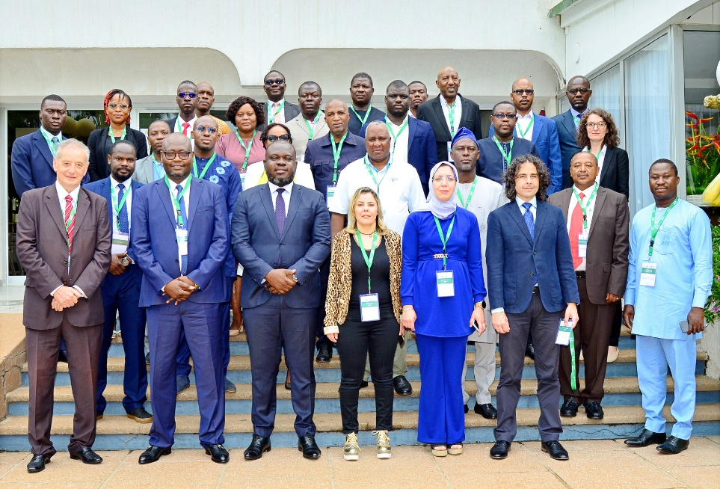
24 - 26 April 2023, Lomé, Togo: The African Energy Commission (AFREC) jointly with the United Nations Statistic Division (UNSD) conducted a three-day workshop to discuss the Strategic Framework for Africa Bioenergy Data Management (AFBIDM).

The objective of the workshop is to provide a platform to African Union (AU) Member States, to share experiences, knowledge, and best practices in the collection, management, and dissemination of bioenergy data o0n the continent as well as enhance capacity of National Statistical Offices and Energy Experts. The workshop was attended by ten (10) AU member states namely: Nigeria, DR Congo, Kenya, Uganda, Cote d’Ivoire, Mozambique, Ethiopia, Eswatini, Tunisia and Togo. Each country was represented by an energy statistician from the Ministry of Energy and another from the countries’ National Bureau of Statistics.

The workshop was officially opened by Mr. Abdoulaye OUEDDO, on behalf of AFREC Executive Director, Rashid Ali Abdallah, thanking the Togolese government, members states and the UNSD close collaboration. Mr. OUEDDO emphasised on the need to identify tools for estimating missing bioenergy data in the members states, taking into account countrie’s needs and real-time situation, support and strengthen bioenergy collection, estimation and reporting abilities.

‘There is an urgent need to implement measures to mitigate the effects of climate change caused by greenhouse gas emissions through reliable and updated data on the production, transformation and consumption of bioenergy energy’, said Mr. SINGO Tchapo, Director General of Energy from the Ministries of Energy and Mines in Togo, representing the Minister in Presidency. Director Tchapo commended AFREC and UNSD efforts to fill the gap in energy statistics and particularly in the bioenergy sector.

Bioenergy is an important and useful energy source in Africa, representing about 50% of the total primary energy supply. Therefore, the importance to enhance the bioenergy data reporting and develop a mechanism to harmonise data collection and management process is fundamental, to enable accurate estimation and reporting on biomass consumption in Africa.

‘Bioenergy is the greatest unknown in terms of energy. The uncertainty clouds our understanding on how best to go about it and ensure sustainable development. Bioenergy also adds great variance to indicators such as SDG 7.2.1 on renewable energy’, said Mr. Leonardo Rocha Souza, Chief, Energy Statistics Section of UNSD.

Henceforth, the AFBIDM framework is the first step towards strengthening the bioenergy sector and can assist decision-makers to better understand bioenergy potential, optimise energy planning and investments by implementing the outcomes, and contribute to a more sustainable future through evidence-based information.

# #
Notes to Editor
About the Strategic Framework for the African Bioenergy Data Management (AFBIDM)
The AFBIDM is policy framework of AFREC which aims at providing guidelines on the roles and responsibilities of AU Member States on the efficient coordination of Bioenergy Data Management in Africa. It encompasses inter-linked sections namely (i) the rationale and the purpose of the AFBIDM; (ii) the context and why bioenergy is important on our continent; (iii) the current status of bioenergy data in Africa; (iv) the guidelines for designing and implementing the AFBIDM; (v) the institutional partnership for a sustainable data management operational framework; and finally (vi) the roadmap and the preliminary budget.
About the African Energy Commission
The African Energy Commission (AFREC) is a specialised energy agency of the African Union, mandated to implement African energy programmes by coordinating, harmonizing, protecting, conserving, developing, promoting rational exploitation, commercialization, resource mobilization and integration of energy resources, for all AU members states. AFREC is also entrusted with the responsibility to design, create and set up the Continental Energy Database, and facilitate rapid dissemination of information among AU member states, Regional Economic Communities RECs) in Africa, investors, amongst others.
For more information, please contact:
- Ms. Ndahafa Nakwafila| Communication and Information Specialist| African Energy Commission (AFREC) | African Union| email: NakwafilaN@africa-union.org| Tel: +213 23 45 9198 | email: afrec@africaunion.org| Website: www.au-afrec.org |Algiers|Algeria Follow Us: Facebook | Twitter
- Directorate of Information and Communication | African Union Commission I E-mail: DIC@africanunion.org I Website: www.au.int I Addis Ababa | Ethiopia

