Press Release No: 7/2022 Date: 03 October 2022
Venue: Cape Town, South Africa

THE AFRICAN UNION JOINS ITS MEMBER STATES AND INDUSTRY PLAYERS IN THE AFRICAN ENERGY SECTOR TO AMPLIFY ITS VOCE AT THE 2022 AFRICA OIL WEEK

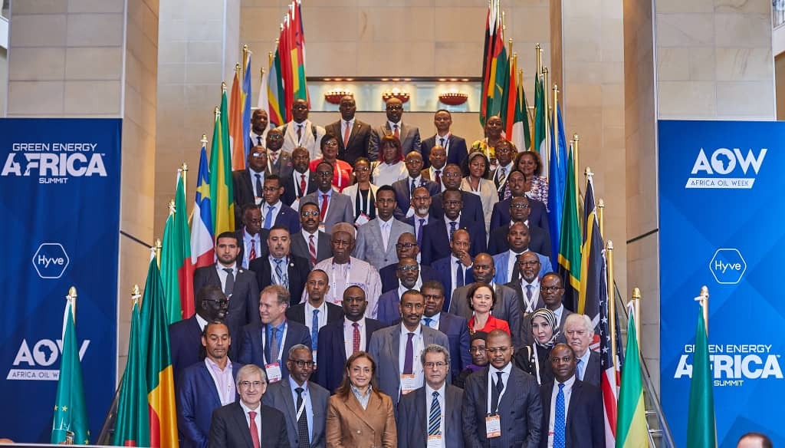
03-04 October 2022, Cape Town, South Africa: - On the sideline of the 2022 Africa Oil Week (AOW), the African Energy Commission (AFREC) in collaboration with the Hyve group organised a Ministerial and VIP Symposium under the Africa’s Energy Transition & Africa Domestic Market for Oil & Gas Production.
The Symposium commenced with a Ministerial Dialogue on 3rd October 2022 attended by more than 25 Ministers from AU Member States to discuss a study report prepared by AFREC on “Africa and the Just Energy Transition: Considerations for the Expansion of the African Oil & Gas Domestic Market”. The report analyses the prerequisites for the establishment of the African Oil & Gas Domestic Market, in cognisant of the advantage for economies of scale offered by African Continental Free Trade Area (AfCFTA), to allow countries with significant oil and gas reserves to develop cross-border infrastructures for trading and processing of crude oil and improve energy access to countries where energy is in significant demand.
The dialogue was followed by an open session on the development of a balance in the energy mix and transition in Africa ending with a plenary session which deliberated on sustainable growth on a low carbon market, on the 4th October 2022.

Her Excellency Dr Amani Abou-Zeid, Commissioner for Infrastructure and Energy at the African Union delivered a keynote address, noting that Africa’s growing population, fast rate of urbanization, ensuring solid energy systems, extending infrastructure, building resilience- among other many pressing challenges- require increasing current rate of energy generation on the continent using all available energy sources.

‘‘The Africa Union Agenda 2063 in alignment with the Paris Agreement, the African Common Position on energy access and African Energy Transition Programme by AFREC are some of the steps which can chart towards the implementation of the Africa’s just energy transition.
Hence, access to affordable energy for productive uses and households in Africa can be achieved mainly by introducing and implementing comprehensive policy tools which can transform the energy sector to amass a big share of renewable resources through an integrated approach, that facilitates the transformation process and attracts the required investment”.

She further said that Africa as a responsible partner in the global fight against climate change, the continent remains committed to the goals stipulated in the Paris Agreement. However, these commitments must consider Africa’s special circumstances, by balancing Africa’s principles on the common situation globally whereas differentiating continental needs given that Africa’s emission is only about 3% and the resources remain unexploited.

Hon. H.E. Gwede Mantashe, Minister of Mineral Resources & Energy for South Africa emphasised on the importance of domestic processing of the mineral resources in Africa for Africa’s development. He enunciated the development of the entire oil value chain in Africa so that communities, youth, women, indigenous populace can benefit sustainably. "Our minerals must be developed and transformed here if Africa wants to develop”. He further said that Africa cannot be importers of oil and oil products while the continent is amassed with abundant crude oil reserves.

Other Honourable ministers echoed a common message, stressing that African countries must ensure that Africa’s pan- African financial institutions should provide adequate support for the expansion of African Oil & Gas Domestic Market.
During the high-level Panel discussion on Natural Gas in the African energy debate moderated by AFREC Executive Director Mr. Rashid Ali Abdallah, panelists recognised that natural gas has a role to play in Africa's sustainable growth. With seventeen countries now producing natural gas and 40% of the world's natural gas discoveries in Africa in last 10 years, natural gas offers a good alternative to fill the continent's energy gaps.
The Africa Oil week continues until 07 October, bringing together AU member states, international development partners, academia and the private sector among others, to discus, share insights and lesson learned from other institutions.
# # #
Notes to Editors
About Oil and Gas in Africa
Oil and Gas are some of the major source of foreign exchange revenues for some producing and exporting countries in Africa. A bulk of Africa oil production occurs in the Central, Northern and Western regions, making the North, South, West and East as the main consuming regions. Oil and Gas accounts for about 50 – 80% of government revenues in some of these countries. However, the impact of COVID-19 on oil prices caused a drastic fall, averaging to around $25 barrel in 2020 compared to $64 per barrel in 2019. The demand of petroleum products increased, and was recorded to 85% in 2020. To advance local value added for the African oil and gas sector, we should therefore aim to create the African domestic crude oil and petroleum products market by developing the required policies, strategies and promote expansion of refinery production capacity and associated infrastructure in Africa. The AfCFTA can facilitates such trade and integration actions.
Natural gas is considered as a transition fuel that can help to meet long-term climate needs in the transition of energy. Increased demand of the fuel has grown, solid growth and new discovery of natural gas are emerging. Natural gas can be used for electricity generation, industry and domestic use. Hence, increasing gas demand across Africa require an expansion and strengthening of the gas network infrastructure to enable cross border trading. Therefore, policy briefs can assist policy makers to understand how gas production and consumption has developed across Africa in the half century, to inform policy opportunity for the future.
AFREC’s report titled: Africa and Just Energy Transition: Considerations for the Expansion of the African Oil & Gas Domestic Market and related appendices can be downloaded from https://au-afrec.org/en/resources/other-publications/oil-and-gas-report-consideration-expansion-africa-oil-and-gas-market

For more information, please contact:
Ms. Ndahafa Nakwafila | Communication and Information| African Energy Commission (AFREC) | African Union | email: NakwafilaN@africa-union.org | Tel: +213 23 45 9198 | www.au-afrec.org|Algiers | Algeria | email: afrec@africaunion.org | Follow Us: Facebook | Twitter|Instagram|LinkedIn@African Energy Commission
Directorate of Information and Communication | African Union Commission I E-mail: DIC@africanunion.org I Website: www.au.int I Addis Ababa | Ethiopia

